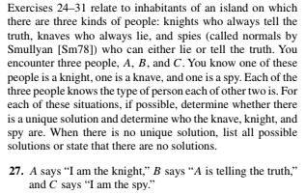

Solution:
Let us assume that C is telling the truth. Then C is a spy. Now one of A and B must be liar because one of them is knave. If A is right, then B is also right. If A is a liar, then so is B. So, there is no possible solution where one of A and B is a liar and the other one is not. So, there is no solution if C is telling the truth.
Now if C is a liar, then he is not knight. He is also not a spy because if he is, then he is not lying. So, C is the knave. There is no situation where one of A and B lies and the other one not. So, if both of them lies, then there is no knight. So, it is sure that both of them is right. So, A is obviously a knight and B is the spy.

